Cyber Resilience Case Study 1:

Impact of Cyber-attack
on Home User

Case Investigator: Biki Maharjan
Submitted to: Richard Copeland
Abstract
Case Investigator Mr. Biki Maharjan was notified by Sharon, a home-user who is a self-employed, mobile pet groomer. She uses various social networking sites such as Facebook and Twitter to advertise her small business. She receives messages regularly through a Hotmail account to make bookings. The laptop she uses has no firewall setup and Avast virus scanner. Like many users she updates only when she remembers and as such her virus definitions and system updates are now out of date.

Contents
1. Executive Summary 4
2. Identification 4
3. Containment 4
4. Investigation 5
5. Impact Assessment 5
6. Recovery 5
7. Notification and Communication 5
8. Evaluation and Improvement 6

Executive Summary
Upon request of Sharon, Case Investigator Mr. Biki Maharjan conducted a thorough check of her digital devices for identification of the attack and plan for further actions as required.

Identification
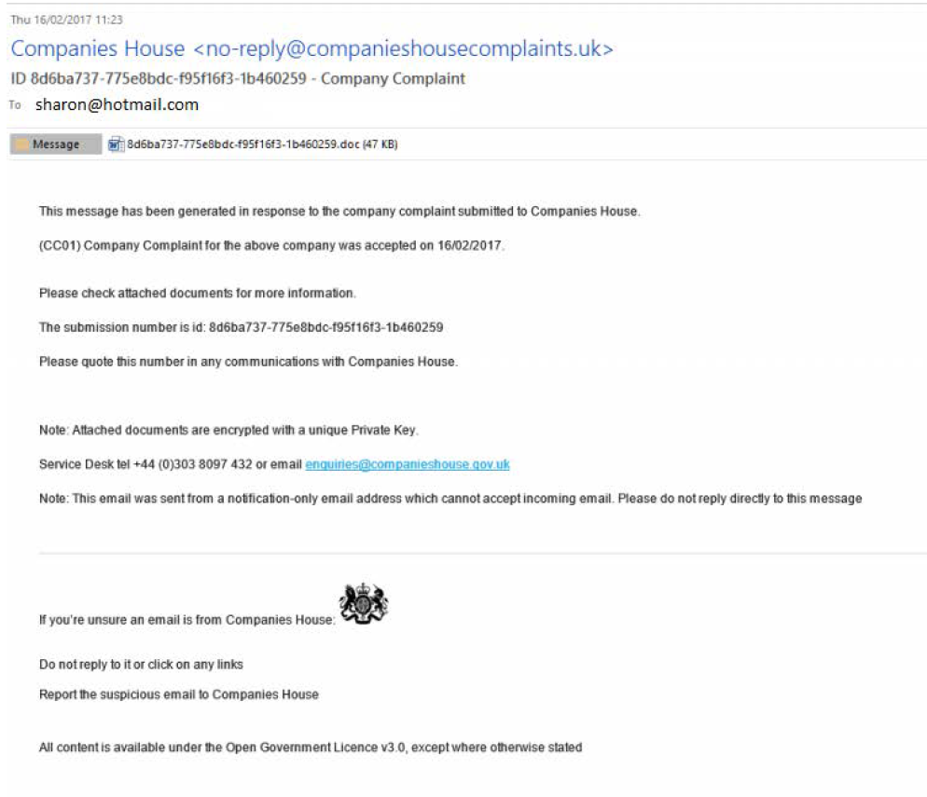
After checking her email “sharon@hotmail.com” , a suspicious email from Companies House(nor-reply@companieshousecomplaints.uk) was found which used a ransomware with a file that Sharon clicked.
Figure 2.1 Ransomware mail
The file was a ransomware sent through a phishing email which locked all her files and the desktop image is showing steps to unlock and decrypt the files. The instructions given will lead to a section where the perpetrators will ask for a ransom for decrypting the files.

Containment
After the identification of attack, the action to contain the damage was set in motion. First, the device was disconnected from the network and instructed Sharon to change all her passwords for social media as well as financial accounts. Furthermore, any demand for ransom should be rejected as there is no guarantee that the perpetrators will restore the files. The laptop was not to be altered in any way until the investigation was completed.

Investigation
Further investigation suggested that the breach was possible due to several factors involved within Sharon’s laptop and her actions as well. Firstly, her laptop had no firewall enabled and her antivirus was outdated. This resulted in malicious files being able to get installed and cause harm to the system. On top of that, Sharon clicking on the ransomware and accepting the agreement prompted on the screen made it worse, giving authorization to the software to do as it liked. The investigation concluded that Sharon’s personal as well as financial data could have been accessed and used for further damage.

Impact Assessment
Considering the investigation and analysis of evidence present, it has been concluded that the breach compromised Sharon’s personal data, business and financial data. Sharon has lost access to her personal files along with her business files she required for bookings and financial records. She will not be able to run the business through online booking as she used to, and her advertising platforms have been compromised as well. In addition to that, the reputation of her business will be affected if any customer information has been compromised.

Recovery
For recovery of the laptop, the device was formatted and a new operating system was installed to ensure the ransomware was removed. Proper firewalls and updated antivirus software are installed for extra security. If Sharon made a backup of the data, the lost files could be restored. In case of no backups, data recovery professionals will be required as all the files are encrypted and normal recovery tools like windows file recovery will not be viable option.
To continue her business, Sharon was advised to change her bank credentials and get a new card. She should be able to do business using her mobile phone until the laptop is recovered with all the data.

Notification and Communication
Following the incident and overall evaluation, it has been certain that personal data of Sharon as well as her customers has been compromised. Therefore, an incident report to the Information Commissioner’s Office should be made. Customers should also be made aware of the current situation and the disruption to the services should also be notified along with an apology.
Releasing a press statement stating the facts is a priority and a sample statement that can be used is:
“We are truly sorry to inform our customers that our system is currently down and there will be disruption of services until further notice due to a cybersecurity incident. We are taking necessary steps to mitigate the issue and secure your data. Due to the nature of incident, we would like to request our customers change their passwords and check for any suspicious email and please do not click on unrecognized web links. We sincerely apologize for any inconvenience caused.”
For any customers wanting to know more, Sharon should be using a FAQ support questionnaire to provide them. Some of FAQ examples are:
- What happened?
A cyberattack in form of ransomware is causing disruption to the network and service.
- What information was affected?
We are not currently sure about the affected area and are doing our best to get access back. Any new updates will be sent to you if required.
- What actions are being taken?
A cybersecurity professional has been hired and recovery process for the system has started.
- Any risk for Customers?
Potential risk of data exposure and phishing is possible to customers. In case of any suspicious emails, please be aware of not opening them.

Evaluation and Improvement
Following the ransomware breach, the response actions were evaluated to determine their effectiveness and identify areas for improvement. While immediate steps such as disconnecting the infected device, resetting passwords, and reinstalling the operating system helped contain the incident and remove the threat, the overall response revealed several weaknesses in preparedness and security practices. The incident highlighted a lack of preventive controls, including an outdated antivirus system, absence of a configured firewall, and no regular data backup strategy, which significantly increased the impact of the attack. Additionally, limited user awareness of phishing threats contributed directly to the compromise. From this event, key lessons were learned, including the importance of maintaining up-to-date security systems, implementing strong backup solutions, and improving user cybersecurity awareness. To strengthen future resilience, a more structured security response plan should be developed, incorporating preventive measures such as automatic updates, multi-factor authentication, regular backups, and basic monitoring tools. Furthermore, establishing a clear incident response framework and conducting periodic security reviews will ensure quicker detection, better containment, and reduced impact of any future cyber incidents.

